CS 255 System Design Document Template

UML Diagrams

UML Use Case Diagram
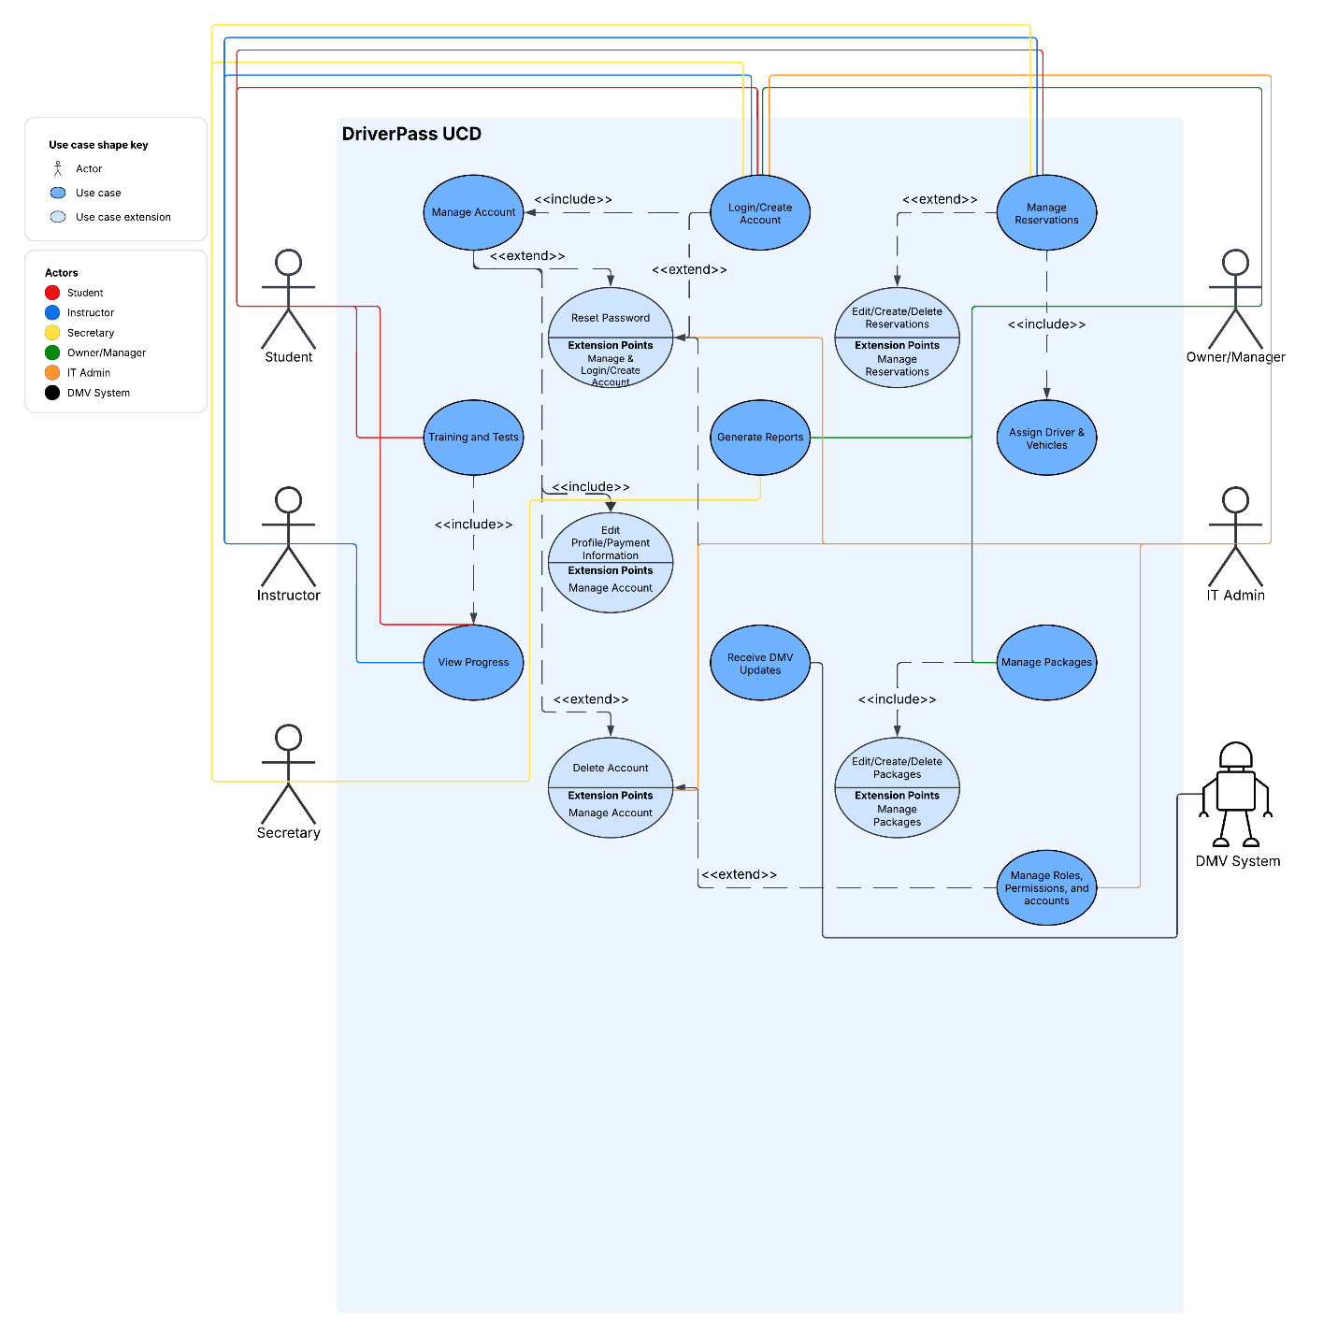

UML Activity Diagrams
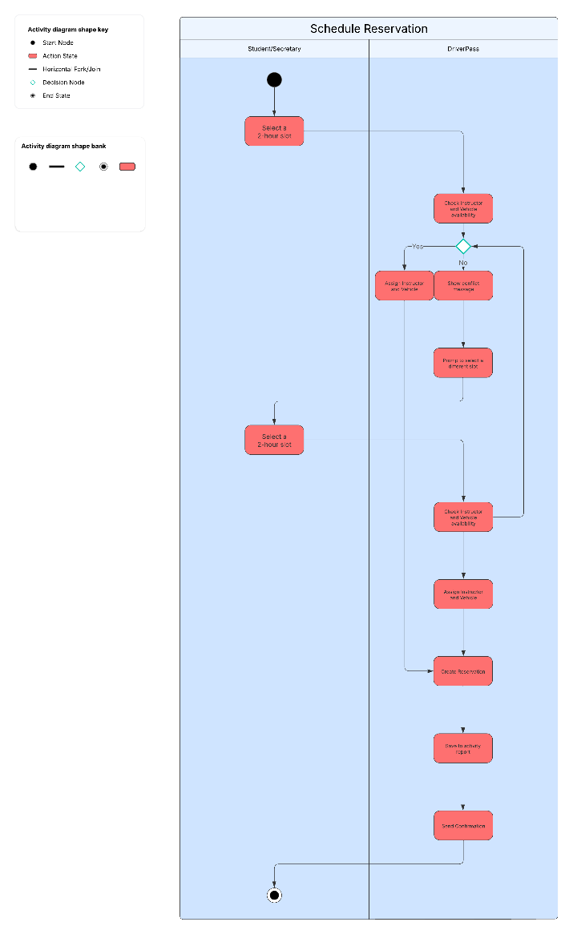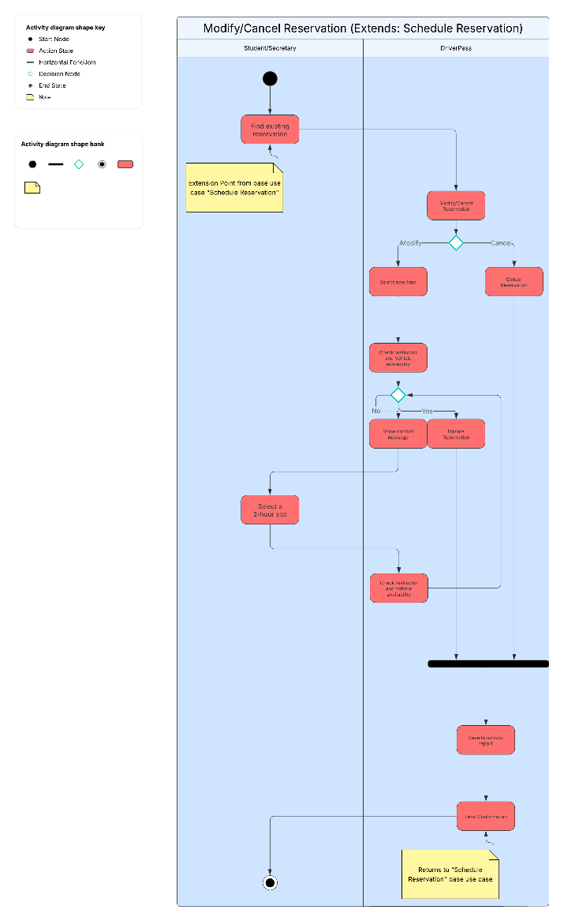

UML Sequence Diagram
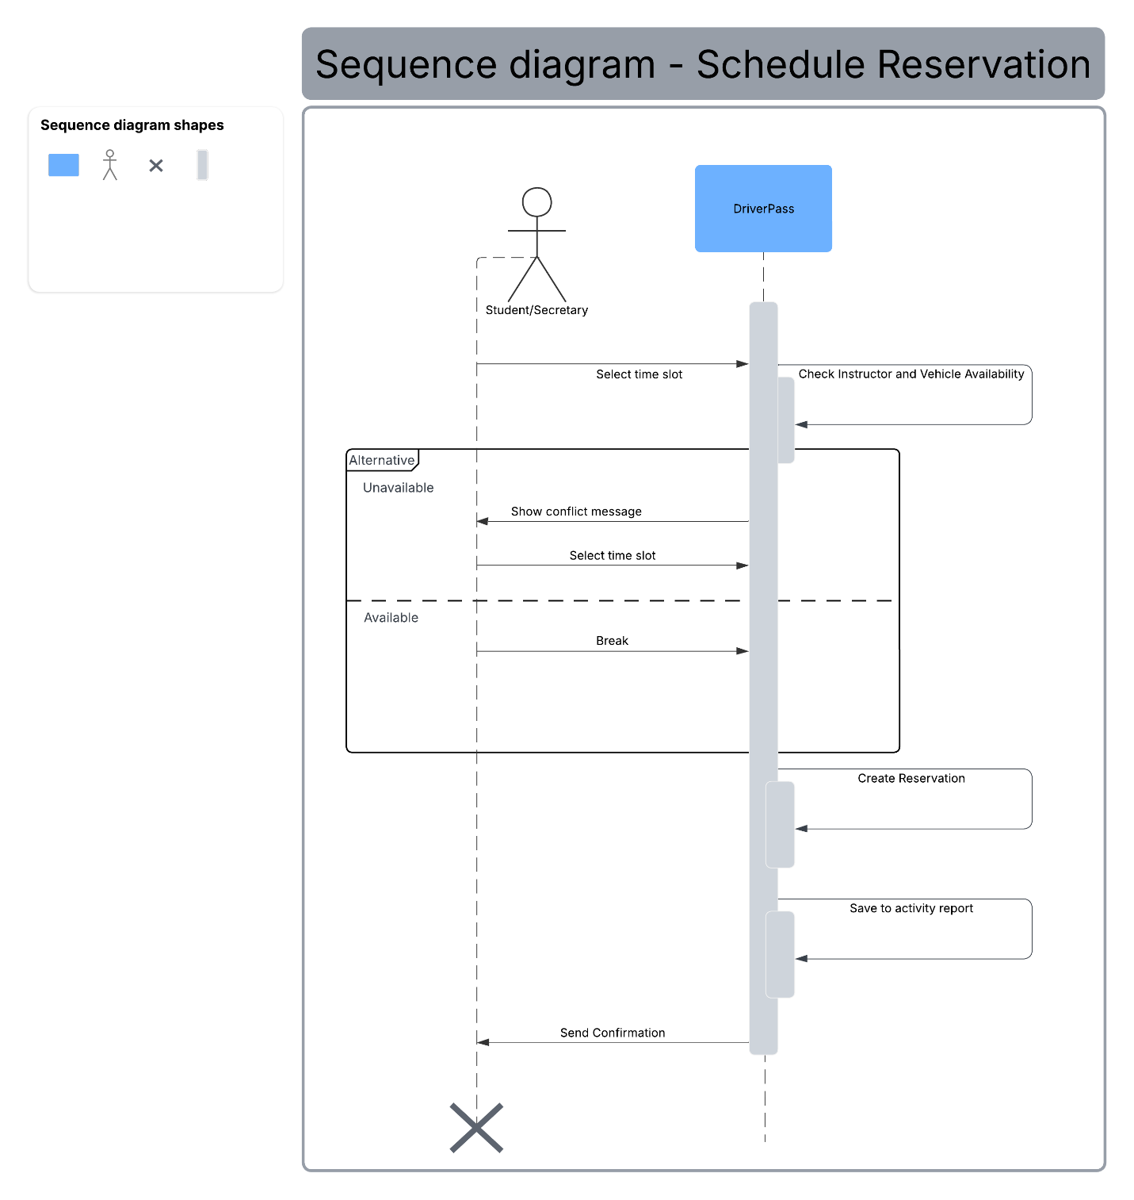

UML Class Diagram
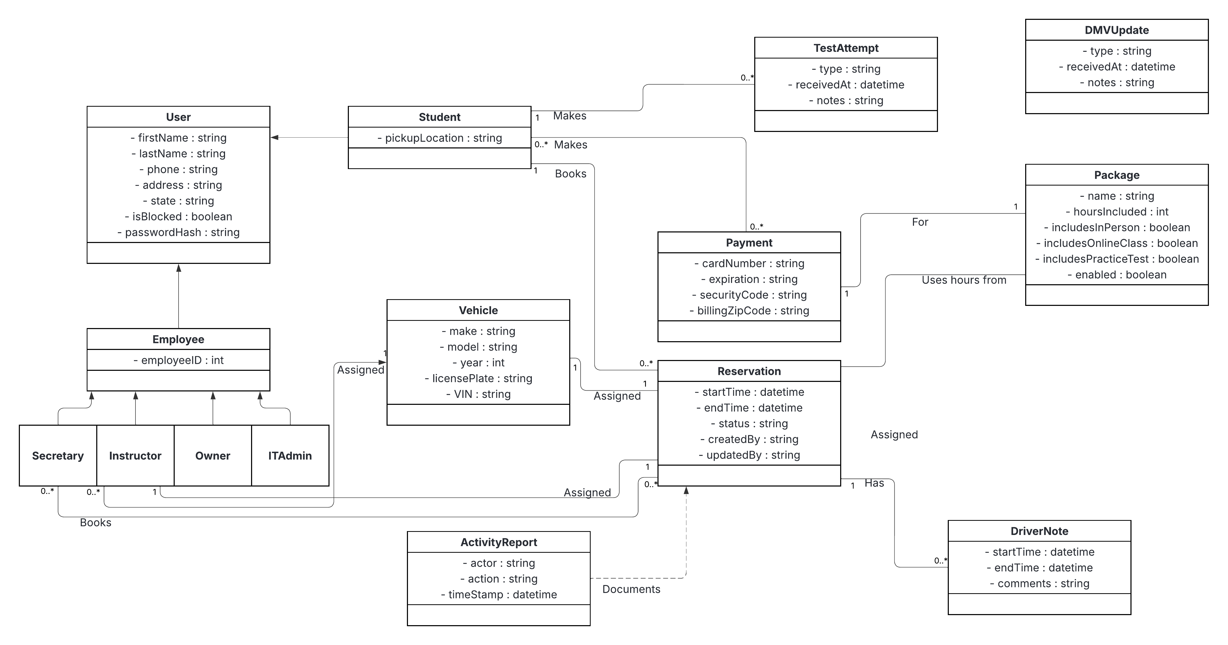

Technical Requirements

- Hardware
  - Reliable and high-speed internet connection at DriverPass Office.
  - Basic network gear such as a router/firewall, office Wi-Fi for employees, guest Wi-Fi, and a network switch.
  - Company Issued tablets and laptops for employees.
  - Printers/Scanners for printing off reports, test results, new DMV policies, etc.
  - Local storage/backup for critical systems.
- Software
  - Standard web front end (HTML, CSS, JavaScript) for desktops and mobile browsers
  - Back-end web service that covers the basic object-oriented functionality.
  - Relationship Database such Oracle or PostgreSQL for keeping DriverPass’s data (Students, Employees, Packages, Reservations, Tests, DMV Updates, Activity Reports, etc.)
  - A secure and compliant payment gateway such as Stripe.
  - Email/SMS service for confirmation and notification updates.
  - Security basics such as HTTPS, passwords hashes, role-based access, IT/Admin privileges,
- Tools
  - Lucidchart for our different UMLs (use case, activity, sequence, and class)
  - GitHub for source control and build/test/deploy steps.
  - Jira for project management (or Trello for something simpler).
- Infrastructure
  - Automated backups to maintain data.
  - Alerts for failures such as in booking, notifications, payments, or DMV updates.

